SYED MOHSIN RAZA NAQVI  (NON-EXECUTIVE DIRECTOR) | 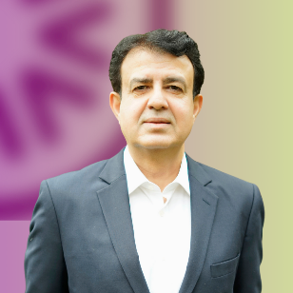

Syed Mohsin Raza Naqvi is a seasoned finance professional nominated by Maple Leaf Cement Factory Limited to the Board of Agritech Limited. He is a Fellow Member of the Institute of Chartered Accountants of Pakistan and brings over 30 years of extensive experience in financial management.
His expertise spans a broad range of areas, including:
• Financial projections
• Forecasting (short-term and long-term cash flows)
• Business strategy development
• Acquisitions and evaluation of business units
• Establishing corporate reporting structures
• Implementing budgetary control procedures
• Deploying financial software solutions
• Organizing finance and treasury functions
Mr. Naqvi currently serves on the Boards of several companies, including Maple Leaf Cement Factory Limited, Kohinoor Textile Mills Limited, Maple Leaf Capital Limited, Maple Leaf Power Limited, Agritech Limited, and Novacare Hospitals (Private) Limited. He is also a certified director from the Pakistan Institute of Corporate Governance.
He previously served on the Board of Kohinoor Mills Limited as well as various other reputable international companies. His career includes international assignments in countries such as Saudi Arabia, Kuwait, the Philippines, Morocco, Jordan, and Pakistan, contributing to his well-rounded global perspective.

