MR. SAYEED TARIQ SAIGOL  (NON-EXECUTIVE DIRECTOR) | 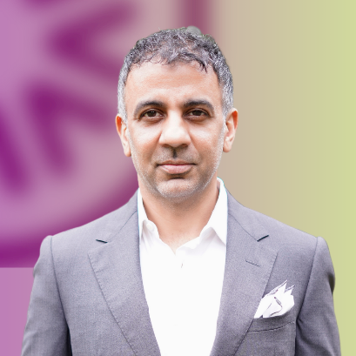

Mr. Sayeed Tariq Saigol is a prominent business leader nominated by Maple Leaf Cement Factory Limited. He currently serves as the Chief Executive Officer of Maple Leaf Cement Factory Limited. Mr. Saigol also holds directorships on the boards of Kohinoor Textile Mills Limited, Maple Leaf Capital Limited, Maple Leaf Power Limited, and Novacare Hospitals (Private) Limited. His leadership across these organizations reflects a deep understanding of the cement, power, textiles, healthcare, fertilizers, and financial market sectors.
Mr. Saigol holds a degree in International Business and Finance from McGill University. This academic background has provided him with a strong foundation in managing business dynamics, financial management, and strategic decision-making skills.
Beyond his current executive roles, Mr. Saigol has amassed several years of valuable experience in the textile industry. His career spans multiple sectors; prior to his tenure at Maple Leaf Cement Factory, he played a pivotal role in the establishment and management of an apparel dyeing company. This entrepreneurial initiative demonstrates his ability to launch and lead business ventures effectively.
In addition to his operational and management responsibilities, Mr. Saigol is committed to advancing education through his role as a member of the Board of Governors at the Lahore University of Management Sciences (LUMS). This engagement highlights his dedication to shaping future leaders and fostering academic excellence.

