LT. GENERAL ANWAR ALI HYDER, HI(M) (RETIRED)  CHAIRMAN  (NON-EXECUTIVE DIRECTOR) | 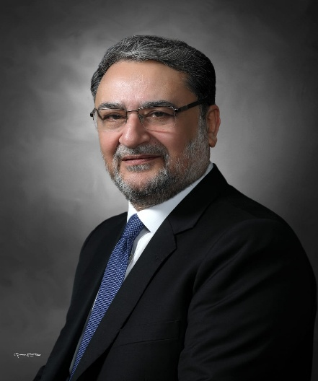
Lieutenant General Anwar Ali Hyder (Retired) brings nearly four decades of distinguished military service and extensive expertise in planning, organization, and administration to his role as a Chairman board of Directors Agritech Limited.
Throughout his distinguished career, he held various prestigious command, staff, and instructional positions, culminating in his role as Principal Staff Officer to the Chief of Army Staff as Adjutant General of the Pakistan Army. In this key position, he demonstrated exceptional leadership and spearheaded numerous significant welfare initiatives and large-scale commercial projects at the Army and national level. Notably, this included strategizing the development and growth of Fauji Foundation Companies and serving as the Chairman of the Army Welfare Trust.
His experience within the Pakistan Army encompasses significant contributions to the planning and development of Defence Housing Authorities (DHAs) nationwide and the supervision of major housing projects such as Askari Housing Colonies. He also has experience in the academic arena, having served as President of the National Defence University and as a member of the Board of Governors of NUST, NUMS, and NUTECH.
Transitioning seamlessly to civilian leadership, Lieutenant General Hyder served as Chairman of the Naya Pakistan Housing and Development Authority (NAPHDA) and as Caretaker Minister for Defence and Defence Production. He was also a member of the Apex Committee of the Special Investment Facilitation Council (SIFC), where he made multifaceted contributions to national economic growth initiatives and in the process remained engaged with several public and private sector entities and multinational organizations.
His strategic prowess and commitment to excellence is complimented by his professional and academic credentials, including a Masters in Strategic Studies from the United States Army War College, Carlisle, Pennsylvania and an MSc in War Studies from the National Defence University, Islamabad.

His dedication and meritorious service in the Pakistan Army were recognized through conferment of Chief of Army Staff Commendation Card and the prestigious Hilal-e-Imtiaz (Military) by the President of Pakistan.
Lieutenant General Hyder's current roles include Managing Director of Fauji Foundation and directorships in following prominent companies.
Listed Companies
- Fauji Fertilizer Company Limited
- Askari Bank Limited
- Fauji Cement Company Limited
- Mari Energies Limited, Mari Mining Company (Private) Limited
- Fauji Foods Limited
Non-Listed Companies
- FFBL Power Company Limited
- Fauji Fresh n Freeze Limited
- Fauji Meat Limited, FonGrow (Private) Limited
- Pakistan Maroc Phosphore SA
- Mari Technologies Limited
- Mari Mining (Private) Limited
- Daharki Power Holding Limited
- Foundation Power Company Daharki Limited
- Fauji Kabirwala Power Company Limited
- Foundation Solar Energy (Private) Limited
- Fauji Oil Terminal & Distribution Company Limited
- Fauji Trans Terminal Limited
- Fauji Akbar Portia Marine Terminal Limited
- MedAsk (Private) Limited, FonGreens (Private) Limited
- FonGreens (Private) Limited
- Fongreen Silicon Technologies Limited
- Foundation University Islamabad (FUI) (President FUI, Vice Chairman Board of Governors FUI, Chairman Executive Committee (FUI).

