MR. JAHANGIR PIRACHA  (NON-EXECUTIVE DIRECTOR) | 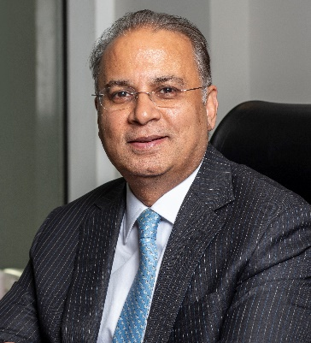

With over three decades of experience, Mr. Jahangir Piracha has built a career dedicated to leading and transforming some of Pakistan’s most influential companies in chemicals, energy and agribusiness. Currently serving as the Managing Director and Chief Executive Officer of FFCL. Mr. Jahangir is focused on driving growth and innovation while supporting Pakistan’s agricultural development and food security.

Mr. Jahangir’s journey includes CEO roles at Engro Polymer & Chemicals Ltd., Engro Vopak & Elengy Terminal Ltd., and Engro Powergen Qadirpur Ltd., where he gained a deep understanding of commercial, manufacturing, human resources, finance and supply chain management. These diverse roles shaped his approach to leadership, emphasizing the importance of viewing challenges from multiple perspectives and balancing immediate needs with a long-term vision.

Beyond his executive roles, Mr. Jahangir has served on numerous boards, including Engro Foundation, REON Energy and Pakistan Oxygen Ltd., where he has played a key role in decisions impacting the future of energy, infrastructure and community support across Pakistan. His commitment to sustainability, inclusion and adaptive growth is evident in the initiatives he supports and the teams he builds.

A Chemical Engineering graduate from the University of Engineering and Technology, Lahore, Mr. Jahangir also completed the Advanced Management Program from INSEAD, Fontainebleau, France. His formal education laid a strong foundation, but his leadership style has been shaped by decades of hands-on experience and a dedication to creating positive, lasting change. Known for his commitment to diversity, equity and inclusion, as well as his advocacy for digital transformation. Mr. Jahangir continues to lead with purpose, building organizations that are resilient, agile and prepared for the future. He also holds directorship on the boards of following companies along with FFCL:

- Askari Bank Limited  - FFC Energy Limited  - Foundation Wind Energy - I Limited  - FFBL Power Company Limited  - Thar Energy Limited  - International Fertilizer Association  - Fauji Foods Limited | - Fauji Fresh n Freeze Limited  - OLIVE Technical Services (Private) Limited  - Foundation Wind Energy - II Limited  - Fauji Meat Limited  - Pakistan Maroc Phosphore SA  - Foundation University Islamabad  - Agritech Limited

