MR. HASAN AHMED  (INDEPENDENT DIRECTOR) | 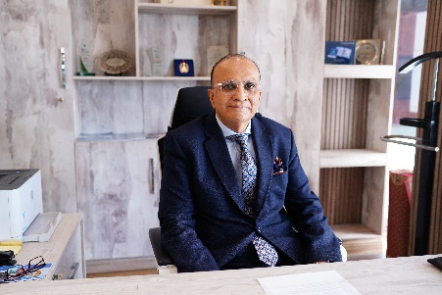

Hasan Ahmed is a senior accounting and financial management executive with over 30 years of experience in finance and operations management within local and global organizations. He has a proven track record of streamlining business operations, driving growth, and improving profitability. His expertise includes financial controls, process improvement, and change management.
Mr. Ahmed has launched greenfield projects across various sectors, including sugar mills, medical facilities, and IT businesses. He has strong connections with financial institutions and experience in capital markets, including syndication, Islamic finance, IPOs, and Sukuks.
His career highlights include structuring syndications and Sukuk transactions, managing IPOs, and restructuring company finances. Mr. Ahmed currently serves on the Board of Directors of Nagina Cottons Mills Limited and AKD Investments Limited. He has also served as CFO Pakistan Cricket Board.
His previous roles include CEO at Dellsons Group, Senior Advisory Board Member at Equity Global Private Limited, and COO at Husein Sugar Mills Limited.
Mr. Ahmed is a Certified Public Accountant (USA). He holds a Bachelor of Commerce degree from the University of Karachi.

